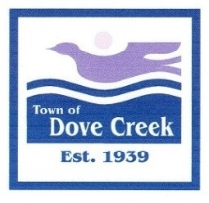

Notice of Increase to Dove Creek Town Sales Tax

The Town of Dove Creek wishes to inform businesses and individuals collecting Dove Creek sales tax and remitting same to the state of Colorado that the amount of tax will increase to a total of 3.1% percent beginning January 1, 2023.

This 1.1% increase was approved by voters at the general election November 8, 2022 and is in addition to the two percent sales tax currently being collected.

For more information, please refer to the State of Colorado Department of Revenue for the Colorado Sale/Use Tax Rates document DR1002 or the Department’s website at https://tax.colorado.gov/ as Dove Creek’s sales tax is administered by the Department of Revenue.

Please implement the necessary updates to point-of-sale systems, software and other billing systems and procedures to begin collecting the 3.1% sales tax from customers beginning January 1, 2023.

Anyone with questions may contact Dove Creek Town Hall at 505 W 4th Street or call 970-677-2255.

Thank you to all the businesses supporting the people in the Town of Dove Creek and surrounding communities.

